Members of the youth, we face a dire predicament with Iran, one that cannot be ignored or passively dismissed. At the moment the U.S. stands on the brink of war with Iran. The US and its European allies have imposed crippling sanctions, a nuclear armed US war fleet and submarines are patrolling the coasts of Iran and US President Obama has stated that "he does not bluff" and that the US would use military force if it suspects that Iran is seeking nuclear weapons. A mysterious string of assassinations targeting Iranian scientists are occurring and various other sabotage operations are proceeding inside Iran. For it's part, U.S. armed Israel is threatening also to initiate an attack on Iran.
Iran has cooperated with international inspectors, has stated that its nuclear program is to provide energy only and there is no credible evidence that it is seeking nuclear weapons. Much like the U.S. drive to war on Iraq fueled by false accusations of weapons of mass destruction, unsubstantiated accusations against Iran are regularly passed along by U.S. leaders of both political parties and the media as if they are truthful facts.

NJ Youth United Against War and Imperialism call upon youth and all people of conscience to resist the inciting of war with Iran that could only lead to the wholesale massacre of the Iranian people. We must demand an end to the sanctions, withdrawal of the nuclear armed war fleet and a halt to the threats being waged daily against Iran.

We must assemble and form a counterculture, based on the preservation of peace and the proliferation of democratic principles. The U.S. working people do not want a war costing billions and causing energy costs to spiral. We want federal funding to go to the education system, to the health care system, to urban development.

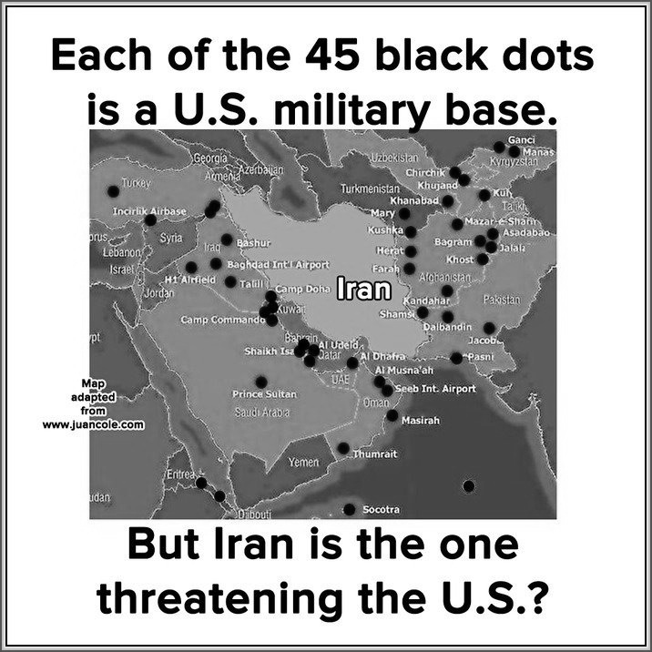
More important than the economic costs of this pending war, if the US carries through on its threat, it will result in the highly immoral wholesale slaughter of Iranian people and possibly others in the surrounding area, as well as the deaths and destruction of the lives of US GIs serving in the operation.

Youth must stop enlisting in the armed forces. We are being used as cannon fodder for endless war. As we protest rising tuition, cuts to public education, attacks on women, on equal rights, police repression in our communities and of our democratic rights and as we join in the Occupy Wall Street movement, we need to bring to the streets a clear message that shouts loud and clear, in our literature, our banners, our signs and our chants: NO WAR WITH IRAN. NO SANCTIONS. NO BOMBING. NO SABOTAGE AND ASSASSINATION. US FLEET OUT OF THE HORMUZ REGION! DEMAND THAT THE U.S. TELL ITS ALLIES IT WILL NOT SUPPORT OR DEFEND AN ATTACK ON IRAN,

